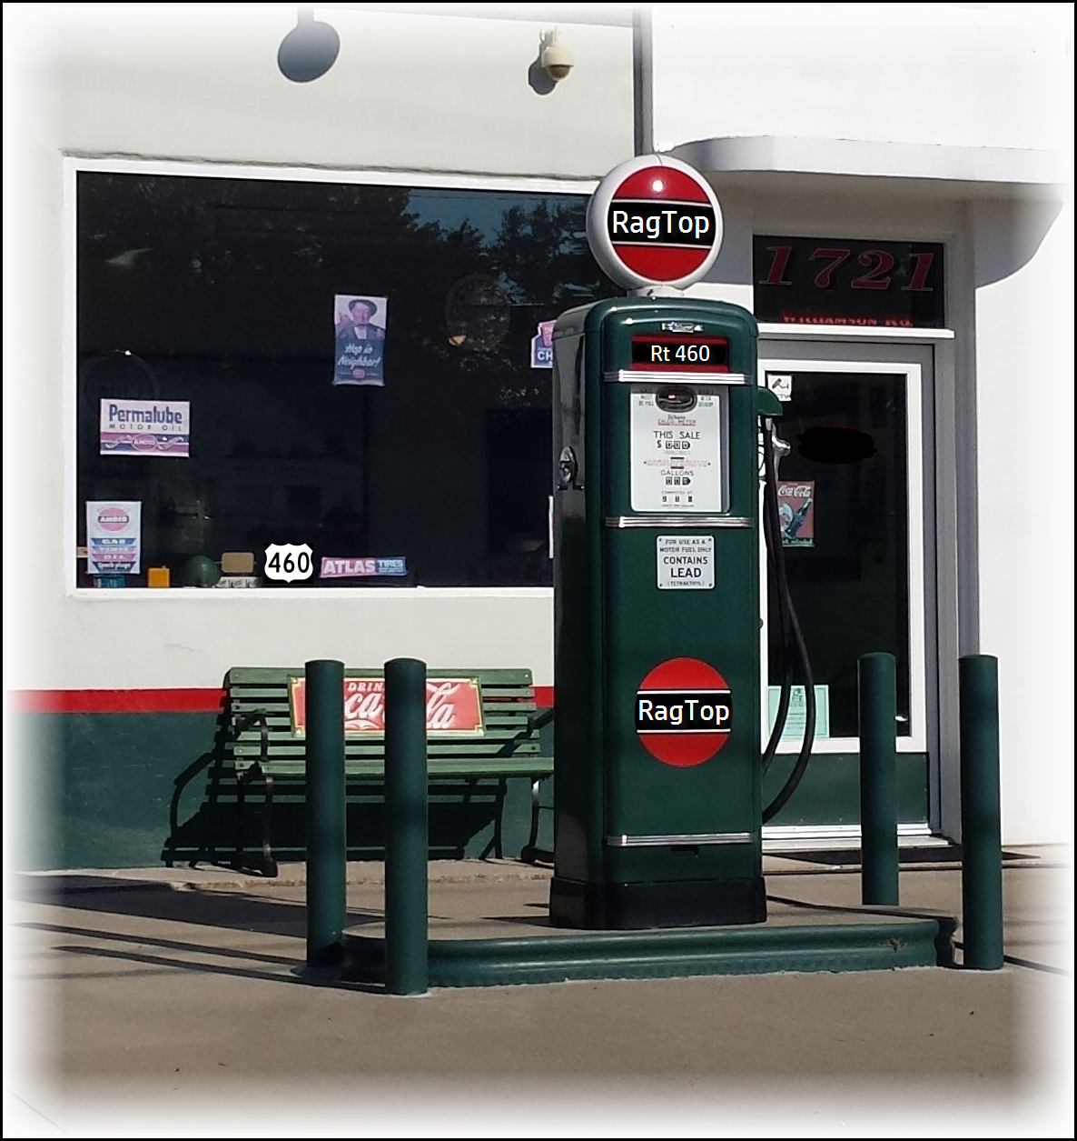 | RagTop Route 460 Liner Notes  This is our 2nd CD. The concept of this CD is based on State Highway Route 460 in our home state - Virginia. We were driving Eastbound on Route 460 out of Roanoke, VA to a show one day and were talking about how many hours we have spent on this highway traveling to our performances over the last several years. It just seemed an appropriate tribute to name our new CD "Route 460".  The songs we selected for the CD are the core of the concept - The songs capture the distinct vibe of RagTop.  As we began to develop the cover art - keeping the concept in mind - we thought that a restored vintage 50s - early 60s gas station would be perfect. The vintage station used for our cover art is located on Williamson Rd in Roanoke, VA - with the photo shoot completed and some photo editing - the cover art was complete.  Songs on the CD include: Wicked Game - Landslide - Keep It Loose - Blue Bayou - Dog & Butterfly - Return to Pooh Corner - Everyday People - Ain't Misbehavin' - Hit the Road Jack - Midnight Train to Georgia - Ocean.
Wicked Game

This is the first song on our new CD - RagTop Route 460! It is a fan favorite, we had several requests to put it on our new album. We recorded this one the same way we perform it live - Jim Loops the rhythm on a Boss loop station. then adds the bass to the loop. Then he can play lead over the loop and add additional rhythm phrases while Renee sings.

The song, "Wicked Game" was written by Chris Isaak and is an emotional ballad about unrequited love. The studio recording gave us the opportunity to have Renee sing her own background parts. The heavy reverb is a signature feel from the original song and really helps set the tone. We hope that you enjoy our arrangement of this classic song.

Featuring: Renee Oliphant, Vocals (lead and background)
Jim Oliphant Guitar, Bass, Boss Loop Station (RC20XL)

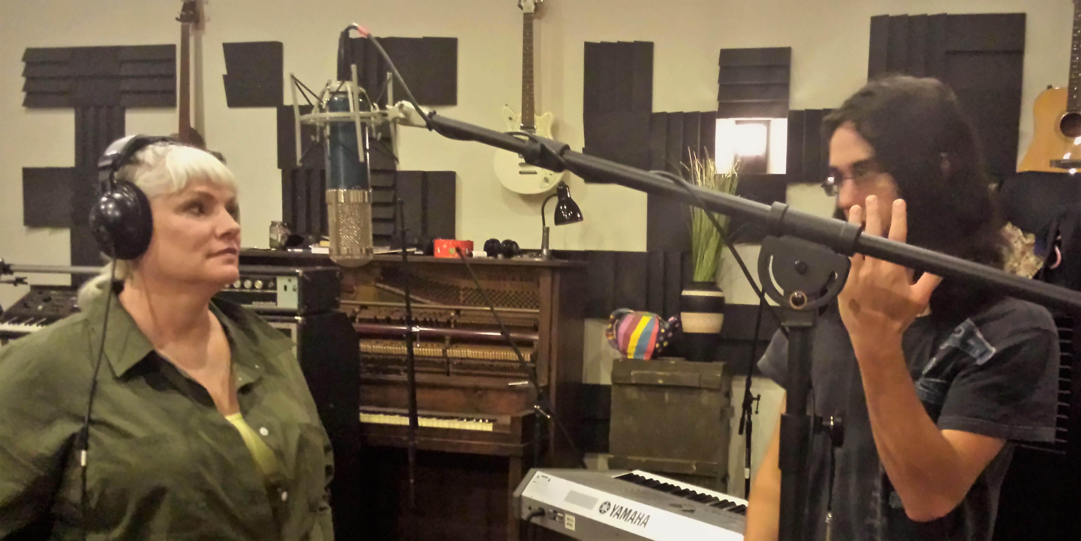  Willy explaining a recording trick the Beatles used called “Flashing” to soften some constant sounds | 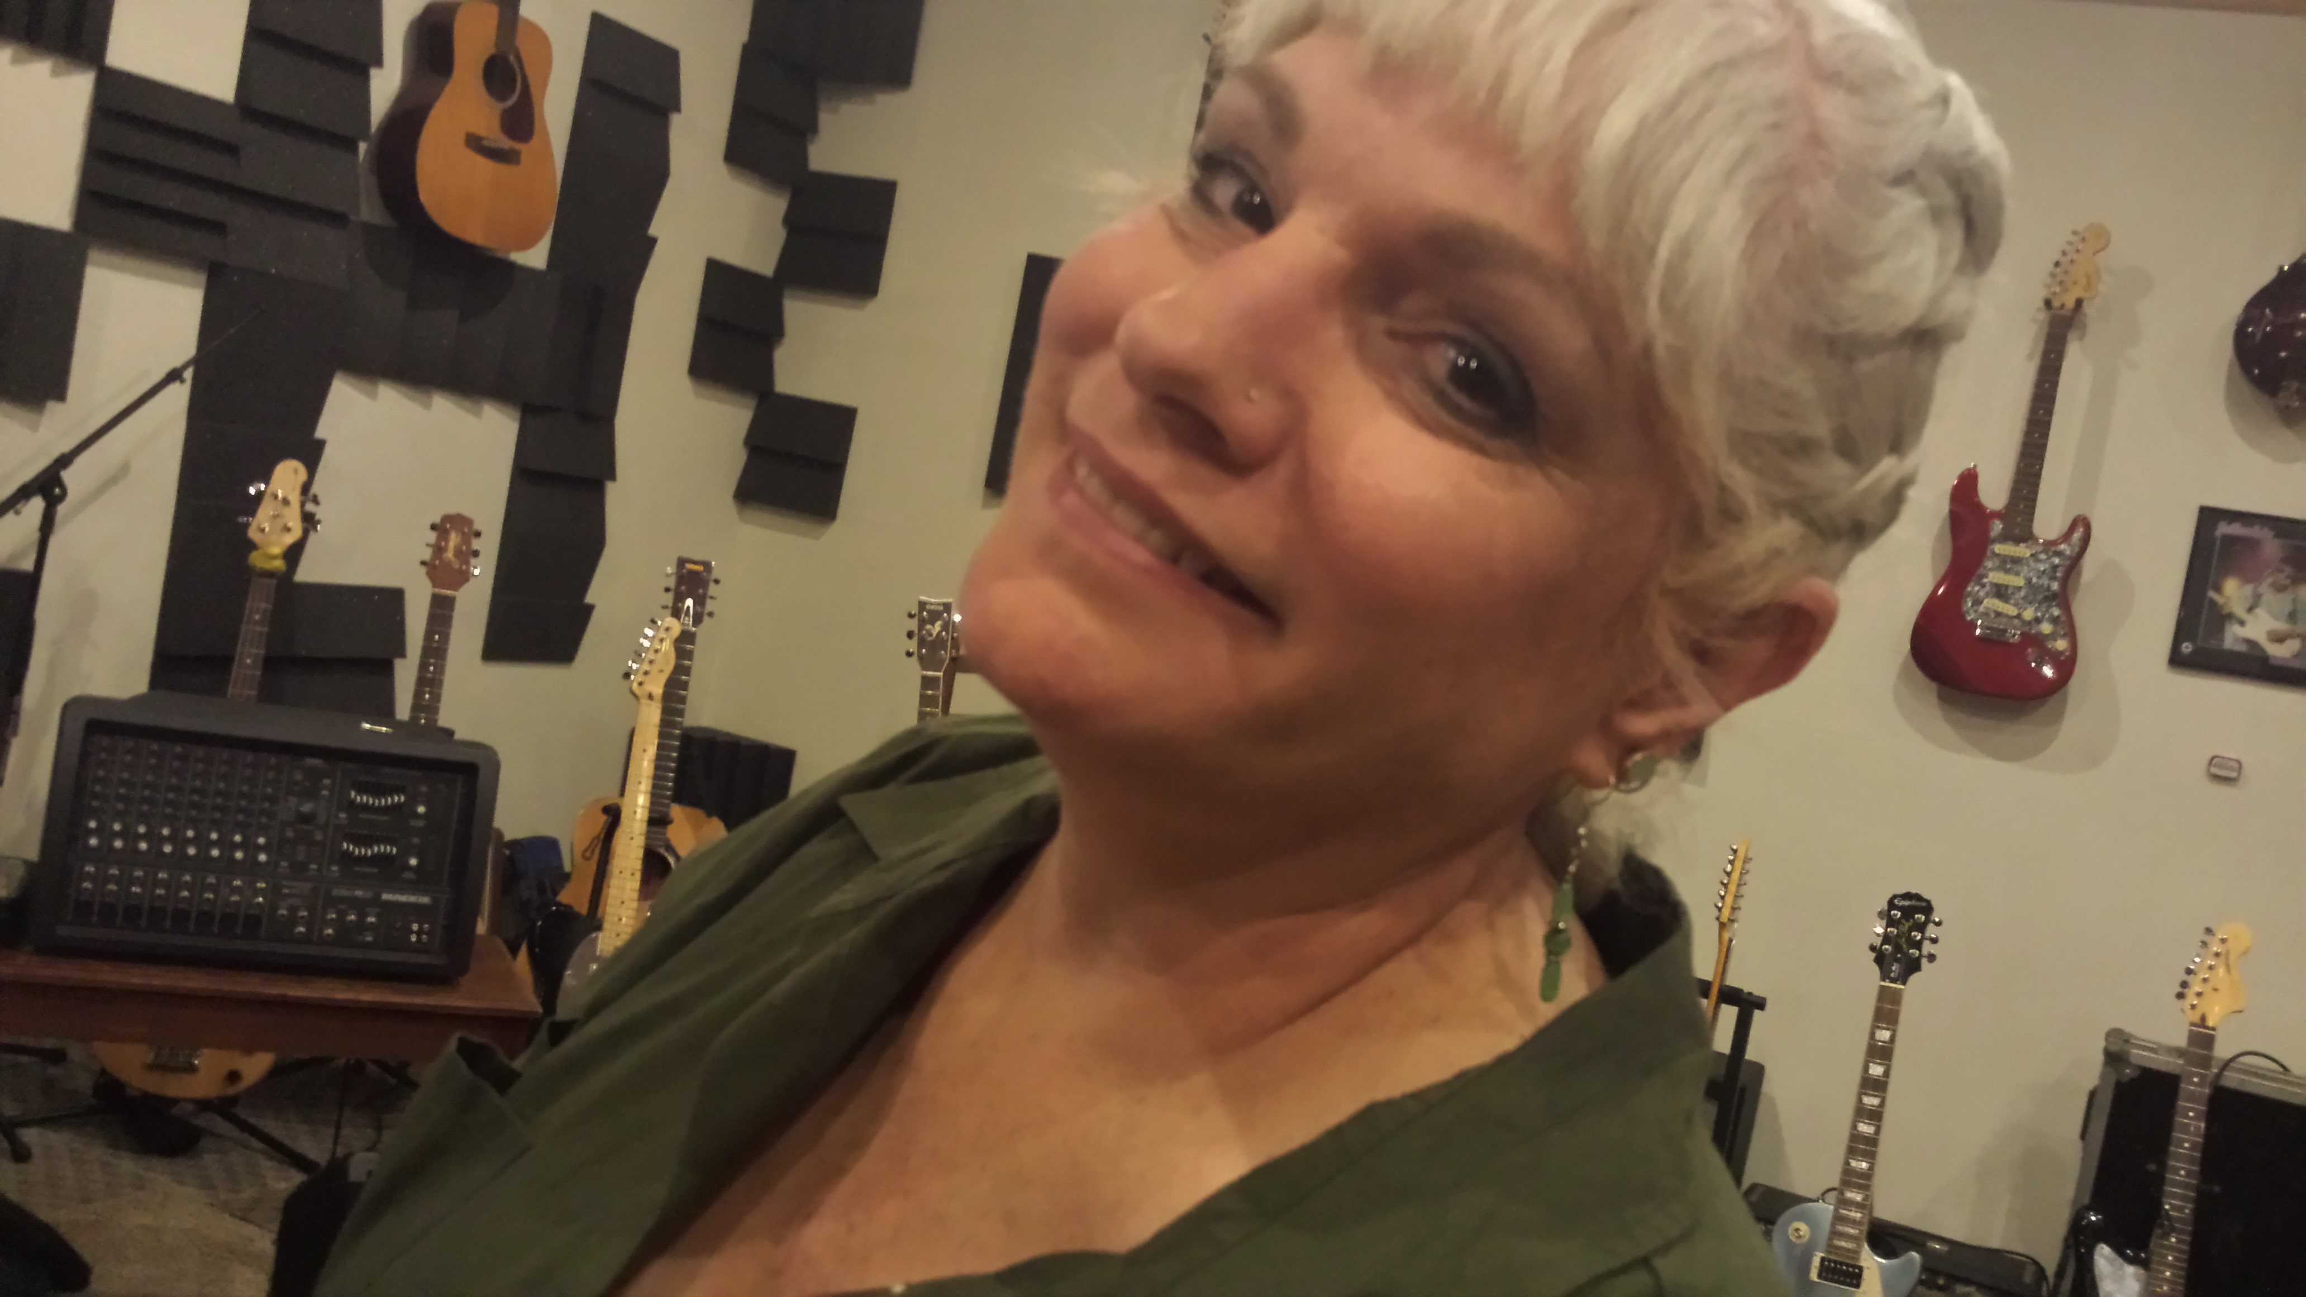  “Here we go!”
Landslide

Landslide was written by Stevie Nicks before she joined Fleetwood Mac. It was at a low point in her life. Stevie and boyfriend, Lindsey Buckingham, were performing as Buckingham Nicks. They had been dropped by their record label and they were not getting along at the time. Nicks says she wrote the song in Aspen, Colorado. She was trying to decide between going back to school or continuing in music with Lindsey Buckingham. Sitting in someone's living room "looking out at the Rocky Mountains pondering the avalanche of everything that had come crashing down on us ... at that moment, my life truly felt like a landslide in many ways".

Our arrangement lays a “Travis”style finger picking technique just under the vocals. No one rocks this technique better than Lindsey Buckingham! (thumb and three fingers with my pinky holding position against the pick guard). I move up in position at one point in the song for a thumb and two finger walk down that lays back further behind the vocals to highlight the change at that point in the song and Renee's alto voice holds a tight melody line. Some fun stuff going on that makes this song so beautiful. This is my favorite song to hear Renee sing!

Featuring: Renee Oliphant, Vocals
Jim Oliphant, Guitar

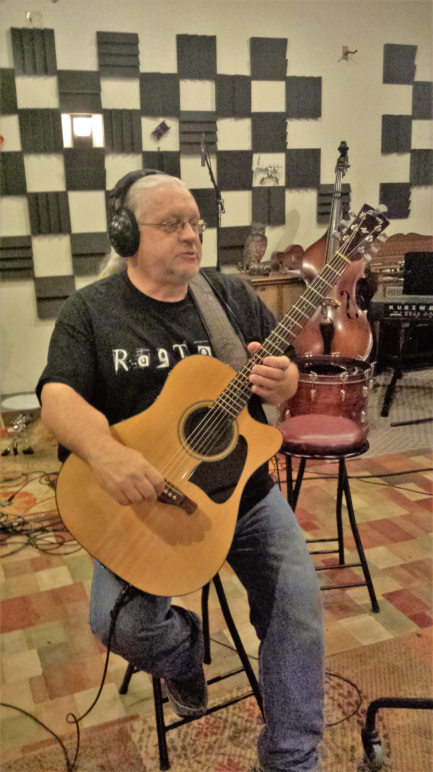  Just before recording “Landslide” |   The studio door – there we are!

Keep it Loose

This song, Keep it Loose Keep it Tight, was written by Amos Lee when he was touring with Nora Jones. He was living in Philly at the time and had a room mate and they were paying $600 a month for rent – they had to move out when the landlord raised the rent to $1400 a month – in the same year. He said he was thinking about that and how people change and what changes them.

Our arrangement stays right on track with the original. Simple suspended chords to give that open-airness feel walking under a solid melody line.

Featuring: Renee Oliphant, Vocals
Jim Oliphant, Guitar

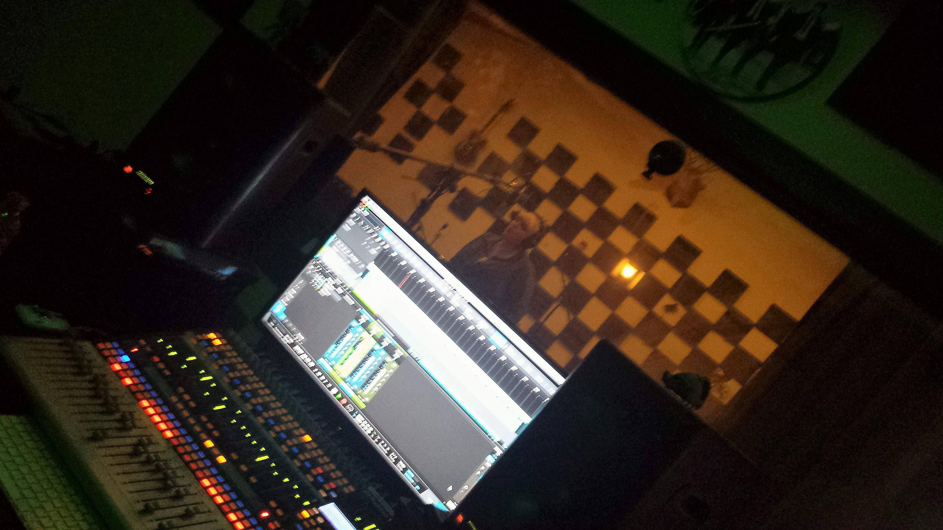  Renee recording the vocals for “Keep it Loose” | 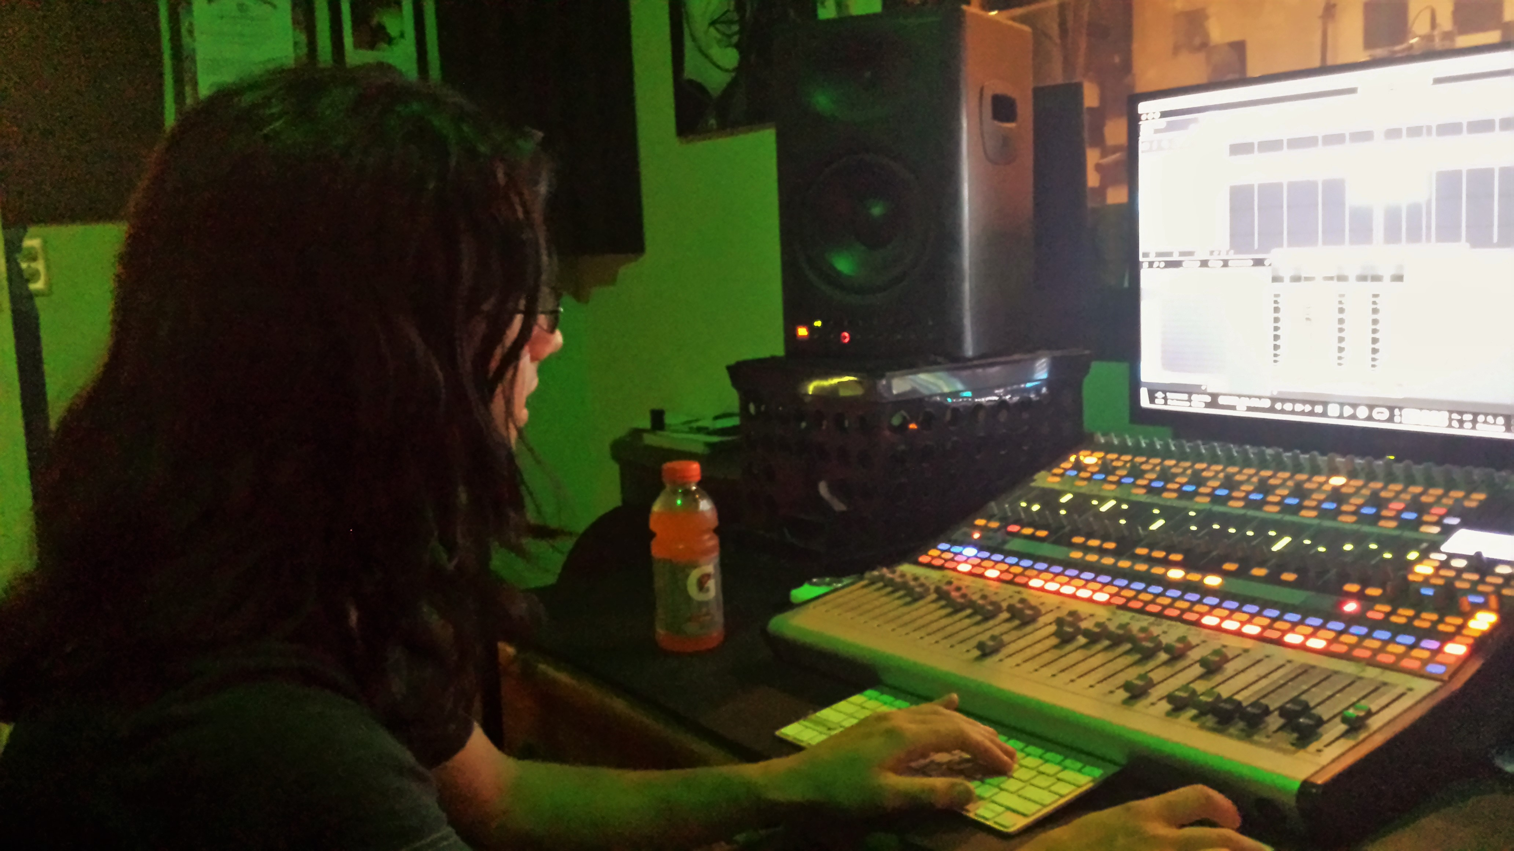  Willy on the boards

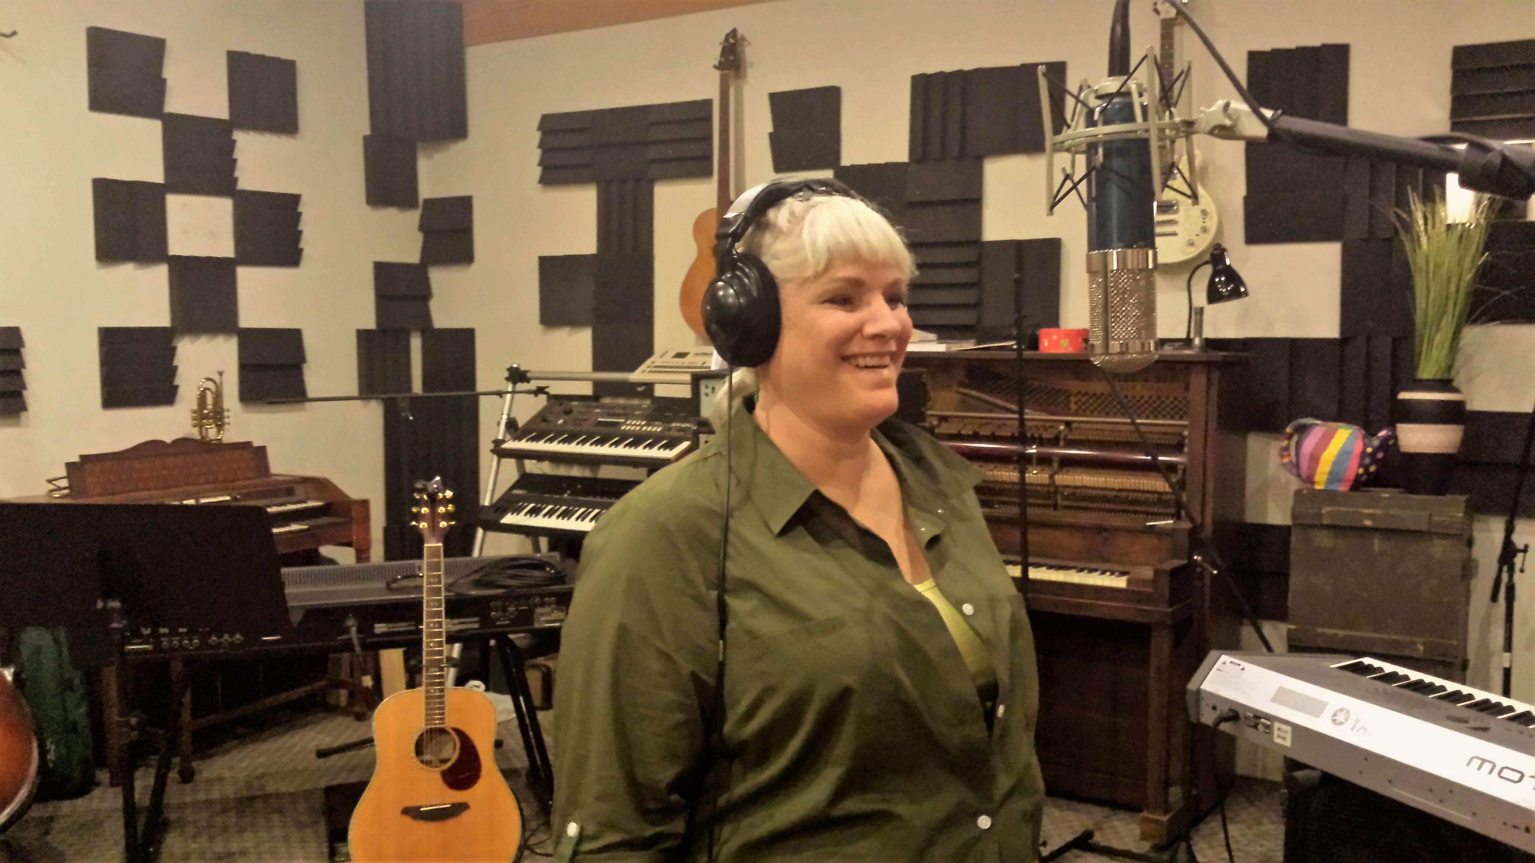  Renee just before recording “Keep it Loose” vocals | 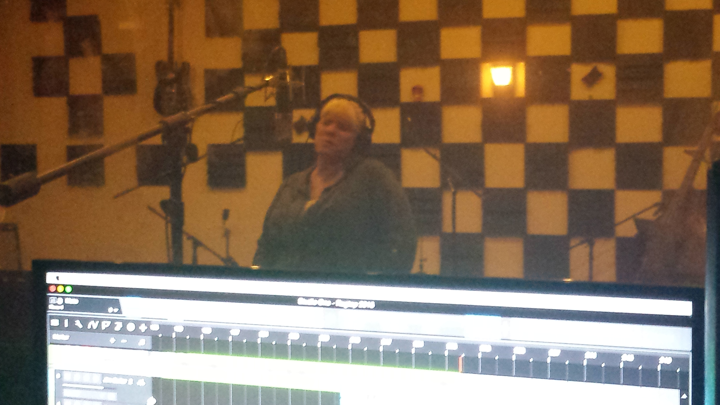  View through the Recording booth window

Blue Bayou

Our arrangement of the song takes a twist on the original song. Roy Orbison wrote this song and recorded it in 1963. In an interview with the British paper NME, he said of the song: "Take a song like 'Blue Bayou' for instance, that's simply a song about being on the road. And that is really a happy song. It probably sounds very strange to you for me to say that. The fellow's bound and determined to get back to where you sleep all day and the catfish play and the sailing boats and the girls and all that stuff. It's a beautiful thought. Now granted that it is a sad song, a lonely song, but it's a loneliness that precedes happiness.”

Linda Ronstadt recorded the song in 1977. She took it to far greater fame as her only gold-selling single and made it her signature song.

Our arrangement of this song is framed by the Linda Ronstadt version but pays tribute to the hauntingly lonely emotion that Roy Orbison could capture. Jim’s guitar work is minimalistic and Daniel Kepel-Young weaves an emotive tapestry on violin throughout the song playing off of Renee’s vocals.

We wanted to capture – vocally - that sense of longing to go back to that special place- voicing the possibility and desire, but we wanted the music to underscore the abandonment – so the listener could feel the harsh reality that you are never going back.

Featuring: Daniel Kepel-Young (Lynchburg Symphony Orchestra Lynchburg, VA) - Violin
Renee Oliphant – vocals
Jim Oliphant – Guitar

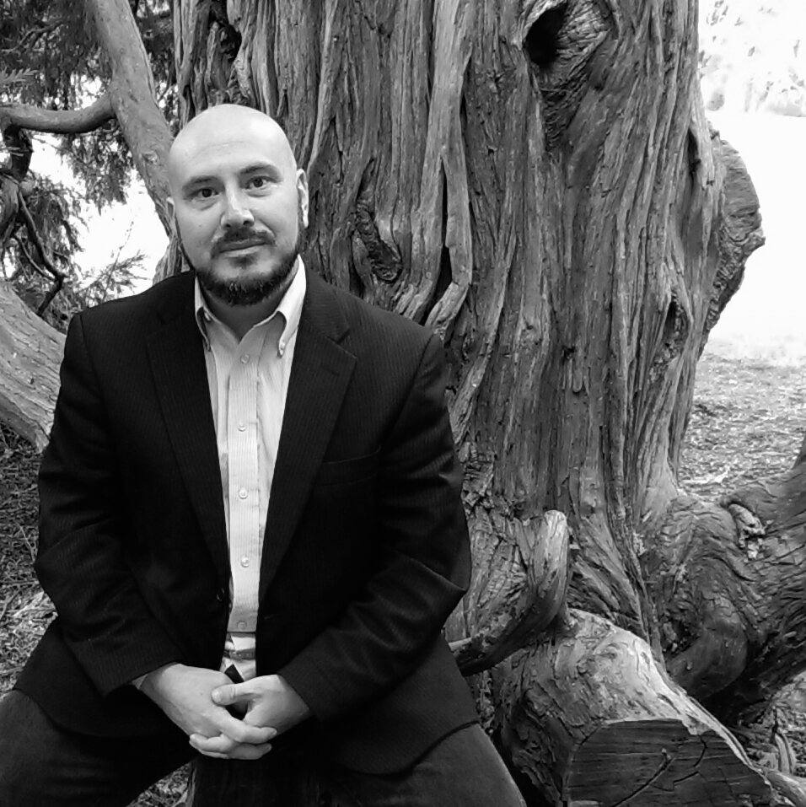  Daniel Kepel-Young | 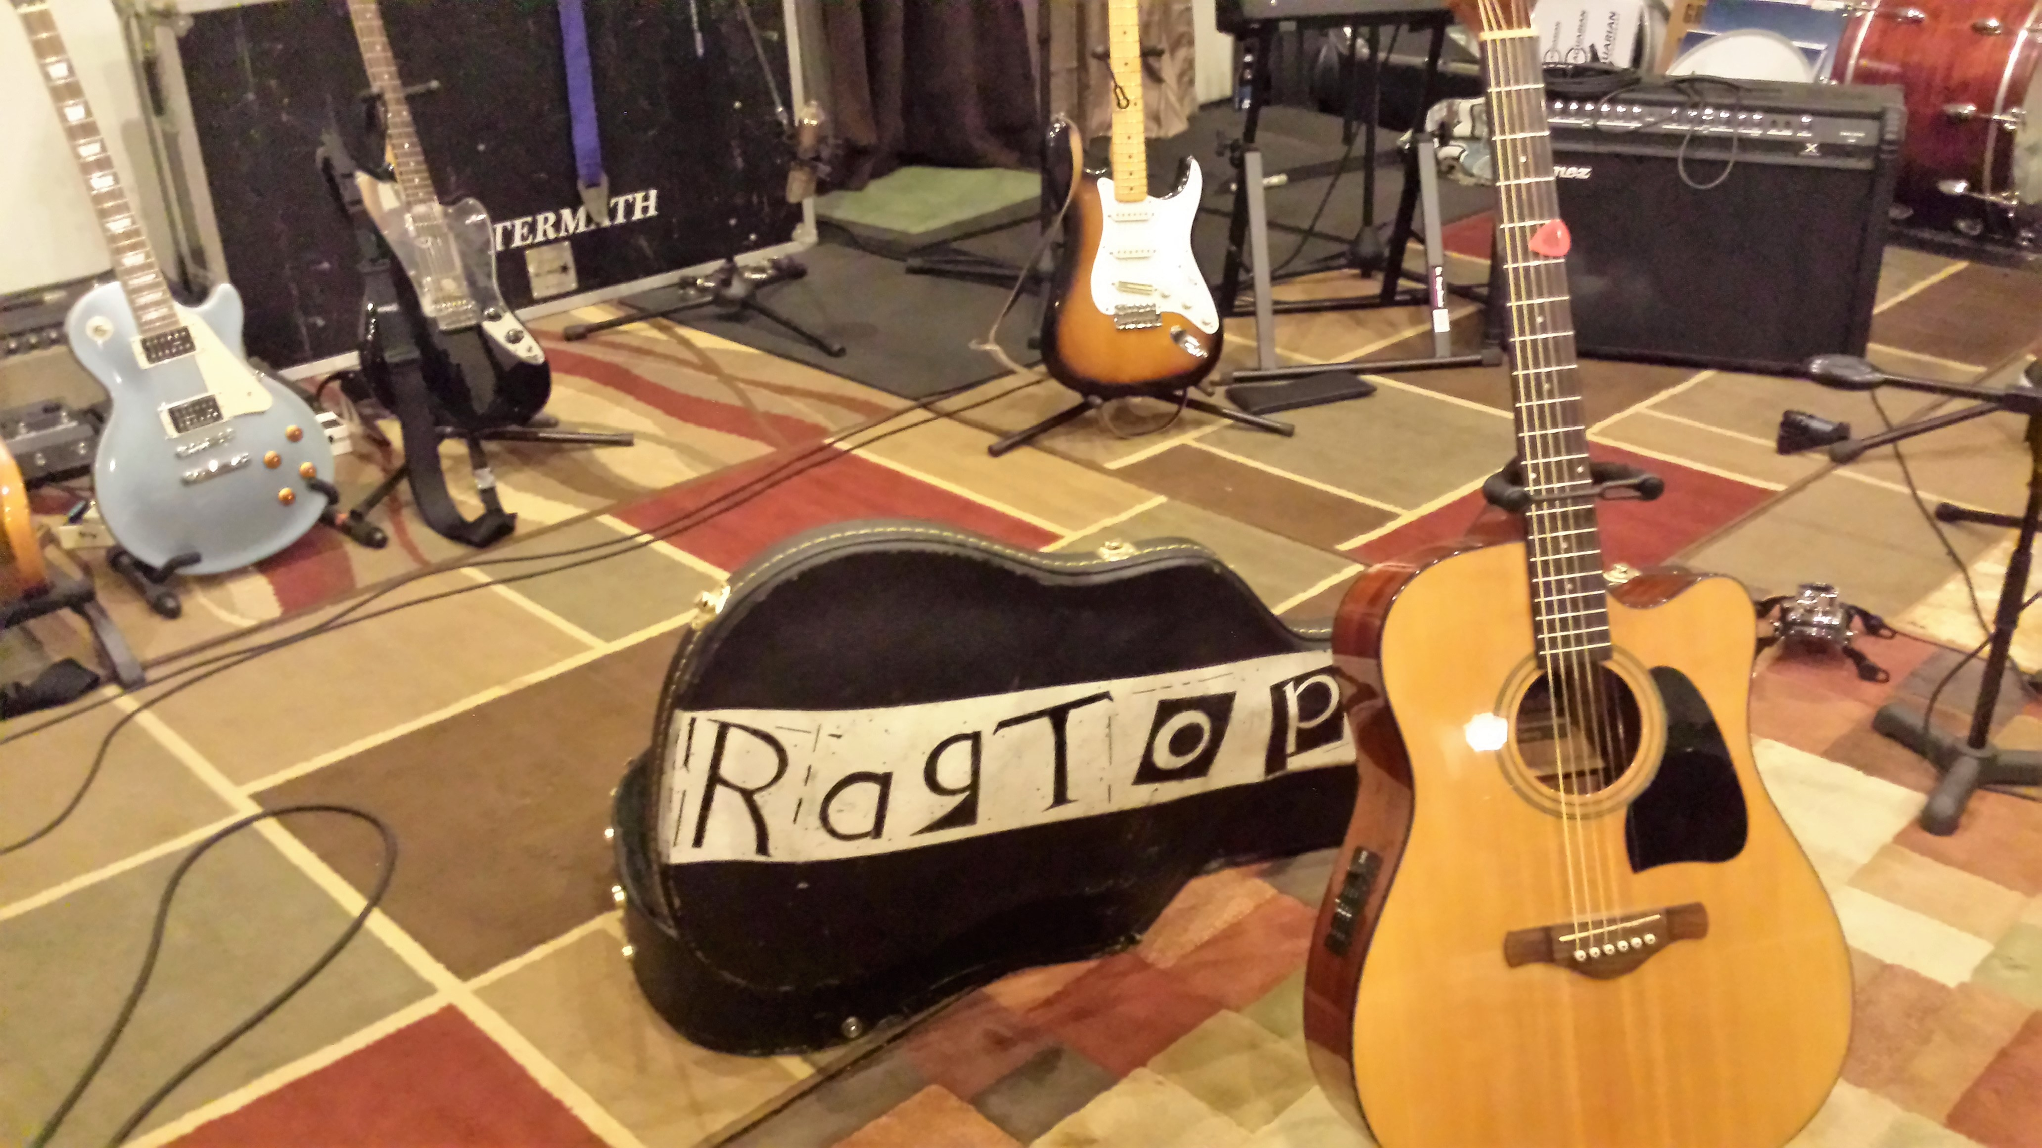  Ibanez Artwood series acoustic  with a G7 capo

Dog & Butterfly
Dog And Butterfly was written by Ann and Nancy Wilson and is the title track to their 4th studio album. Ann says, about writing the song, “I was upstairs in my music room waiting for my muse. It doesn’t always happen on cue but, in hindsight, it did this time. I looked out of my window and saw the dog chasing a butterfly. He wouldn’t give up; he just kept chasing that butterfly. I thought it was impossible, yet he kept on going. The chase took on another meaning for me. Like so much in life, the spirit is undaunted, you keep going after it.”
It is the classic, “'man's reach must exceed his grasp” - For our arrangement of this song we wanted to be as true to the original as we could – the guitar needed to weave its way throughout the vocals while leaving room for Renee to lead the listener to visualize this great lyric-story. We recorded this song together – vocals and guitar at the same time – rather than laying down a guitar track and then the vocals.
I have to say that Ann and Nancy Wilson have influenced us in so many ways. The powerful vocal emotions of Ann and the guitar guru work of Nancy are artistic beauty!
Featuring: Renee Oliphant, Vocals
Jim Oliphant, Guitar

  Willy on the board – running the playback  (fainting Goat Studio Bedford, VA) | 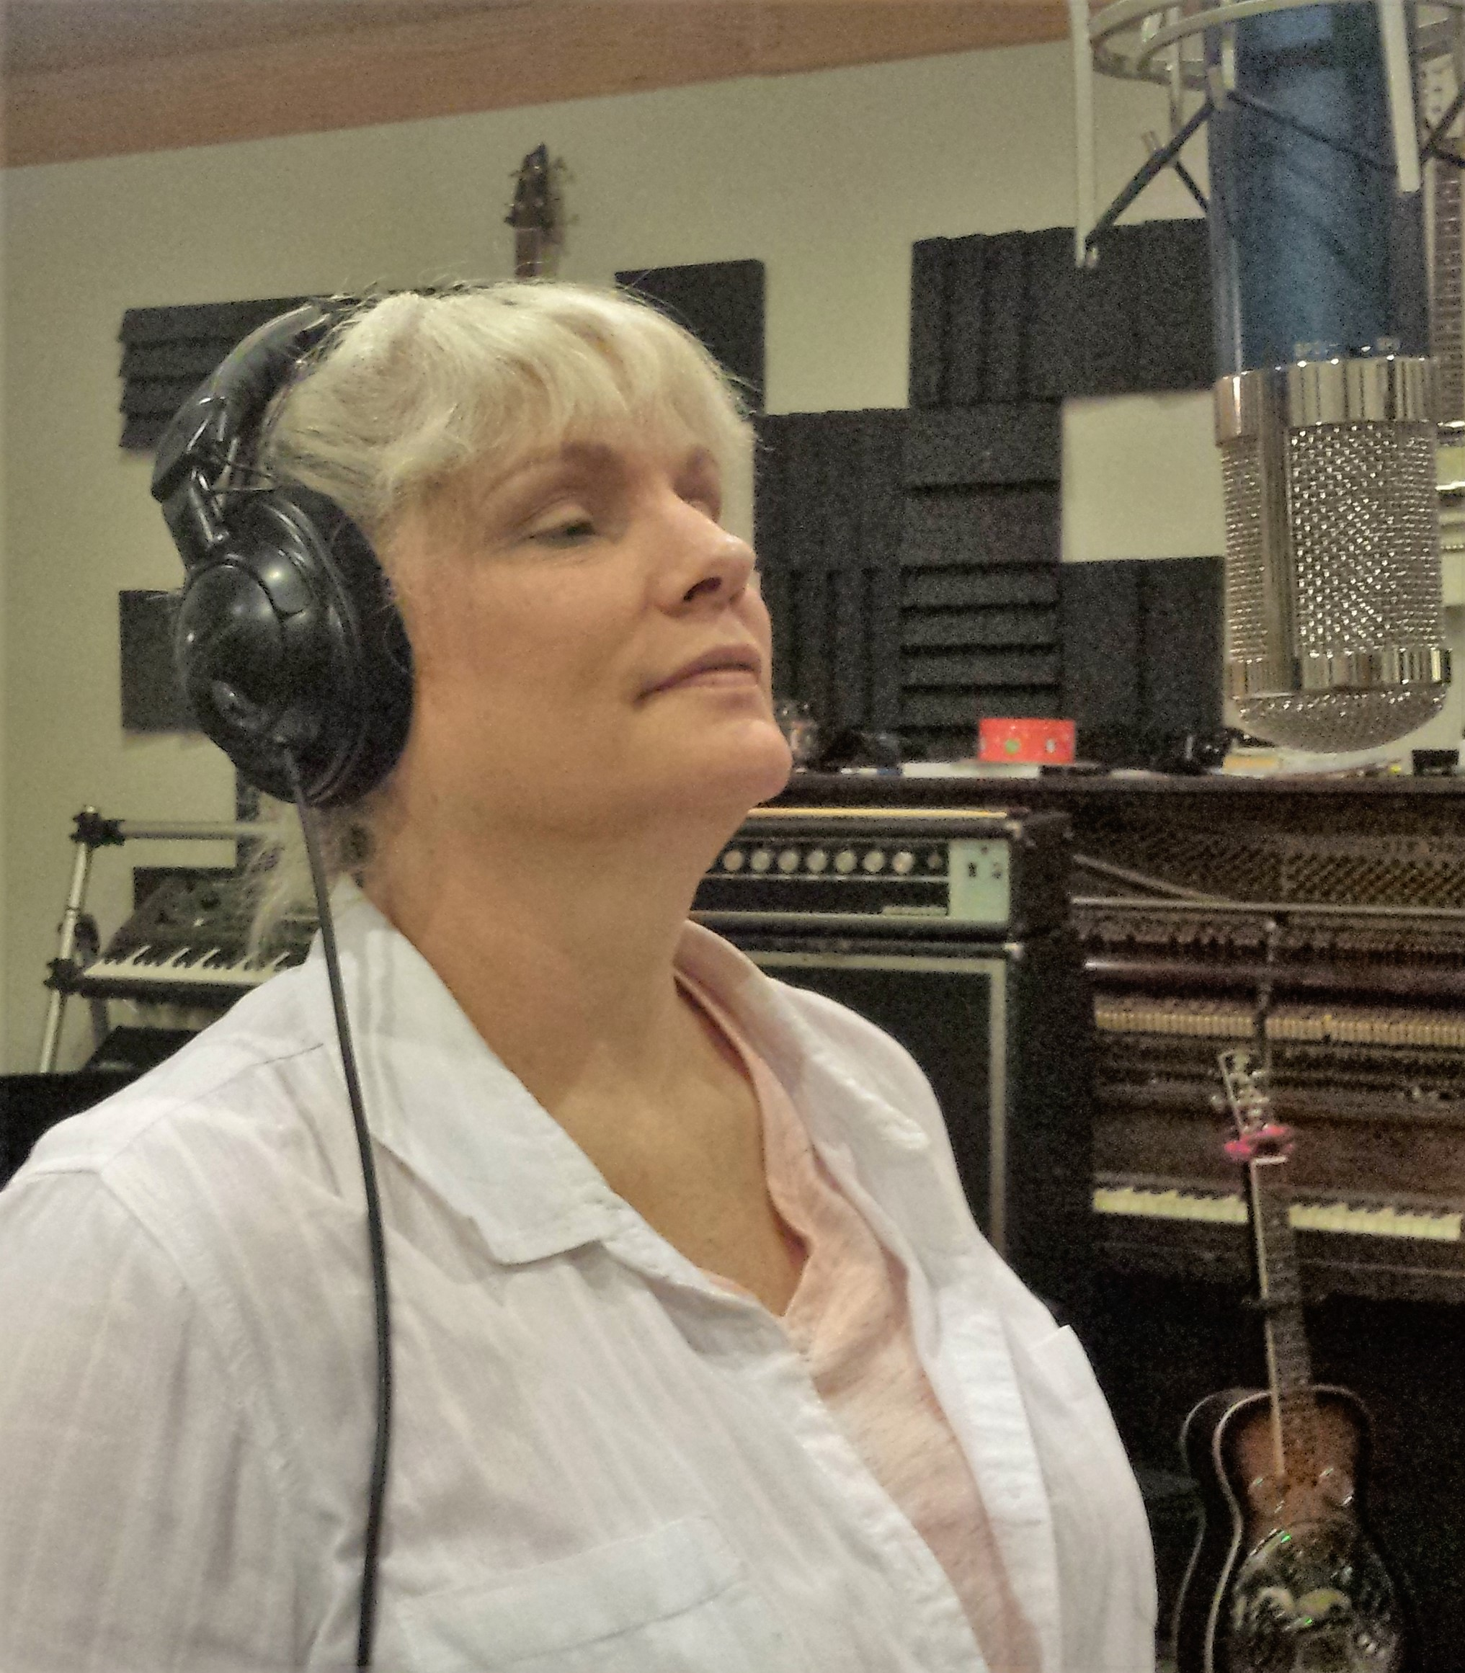  Renee listening to the playback of the song


Jim and Willy working through song order and the data info for each song

Return to Pooh Corner
Kenny Loggins wrote House at Pooh Corner when he was 17 years old and in high school. The song has a nostalgic longing for childhood days gone by and was first recorded by the Nitty Gritty Dirt Band. Return to Pooh Corner was written some 20 plus years later after he had his third child. He felt like the song needed a verse from a dad's perspective. Kenny Loggins re-recorded the song as a duet with Amy Grant and backing vocals from Amy's grant's then-husband, Gary Chapman.
Our arrangement is in keeping with the original. A simple, guitar line that follows the melody with a frolicking tempo. The last verse that Loggins added slows to draw the listener in to understand that the boy that wandered too far and left Hundred Acre Wood was a father now and - finds his way back – rediscovering that part of himself he had left behind.
This song has always had a special meaning to me. We named our first born son after the character Christopher Robin (Kristopher).
Featuring: Renee Oliphant, Vocals
Jim Oliphant, Guitar

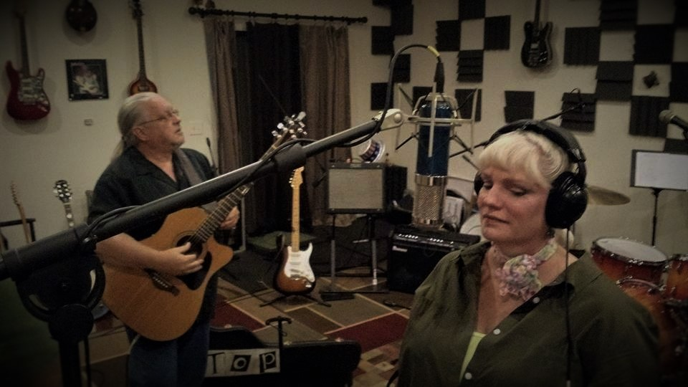 | 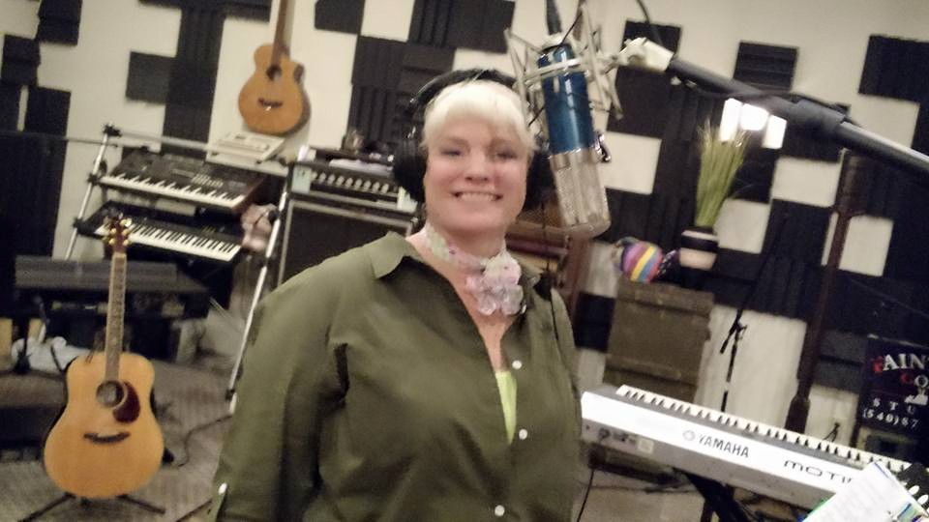

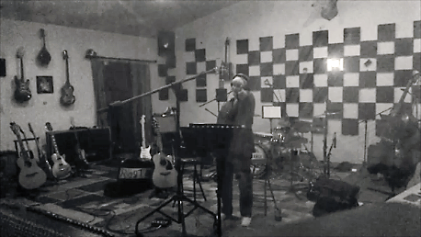

Everyday People
"Everyday People" is a 1968 song by Sly and the Family Stone. It went to number one on the soul charts. The song is a plea for peace and equality between differing races and social groups. The Family Stone was the first major integrated band in rock history. Sly & the Family Stone's message was all about peace and equality through music.
Our arrangement is based on the Forest Rangers version that was recorded for the Sons of Anarchy series. Katey Sagal, who play Gemma in the series, also sang on the song.
On our arrangement, Renee sings her own harmony parts. We are old school about this – Renee actually sang the harmonies – no “Harmonizers” or “Auto Tune” - the real deal to capture all the mojo because, well – the girl can sing!
Featuring: Renee Oliphant, Vocals and Harmonies
Jim Oliphant, Guitar

   | Final mix down of harmony parts

Ain't Misbehavin'
This song was written by Fats Waller in 1929. It was considered Stride Jazz or early swing music. According to Fats Waller, who had a habit of embellishing stories, he wrote the song while in Alimony prison. Knowing that, the lyrics take on a more playful meaning. He couldn't misbehave, he was in jail – the shelf was his simple jail bed – in by 8 when the work crews came in for the day – and nothing to do but listen to the radio.
What we wanted to do with our arrangement is capture a bouncy, tongue-in-cheek feel that were reflected in Waller's live performances of the song. At one point in his live performance, when he sings, “saving all my love for you.” he adds, as he points out various pretty ladies in the audiences, “ . . . and you, and you!”
Our inspiration for putting this song on the album comes from a Jack Johnson CD. In Between Dreams (2005) he has a very short, light-hearted song that he sings first in Italian, then in Spanish, then in French and then, ends in English. It just catches you by surprise. We had been messing around with “Ain't Misbehavin'”and said, “Yea! Let's drop that in the middle to catch the listener by surprise.”

Featuring: Renee Oliphant, Vocals
Jim Oliphant, Guitar

Hit The Road Jack
The Grammy winning song, "Hit the Road Jack" was written by Ray Charles friend, Percy Mayfield and first recorded in 1960 It became famous after it was recorded by Ray Charles with The Raylettes vocalist Margie Hendricks.
Our arrangement is looped on a Boss loop station. First I play the rhythm and record that on the loop. Next I add a percussive scratch beat to the loop. That allows me to play lead over the rest of the song while Renee sings. This is a fun song to perform live.

Featuring: Renee Oliphant, Vocals
Jim Oliphant, Guitar, Boss loop station (RC20XL)

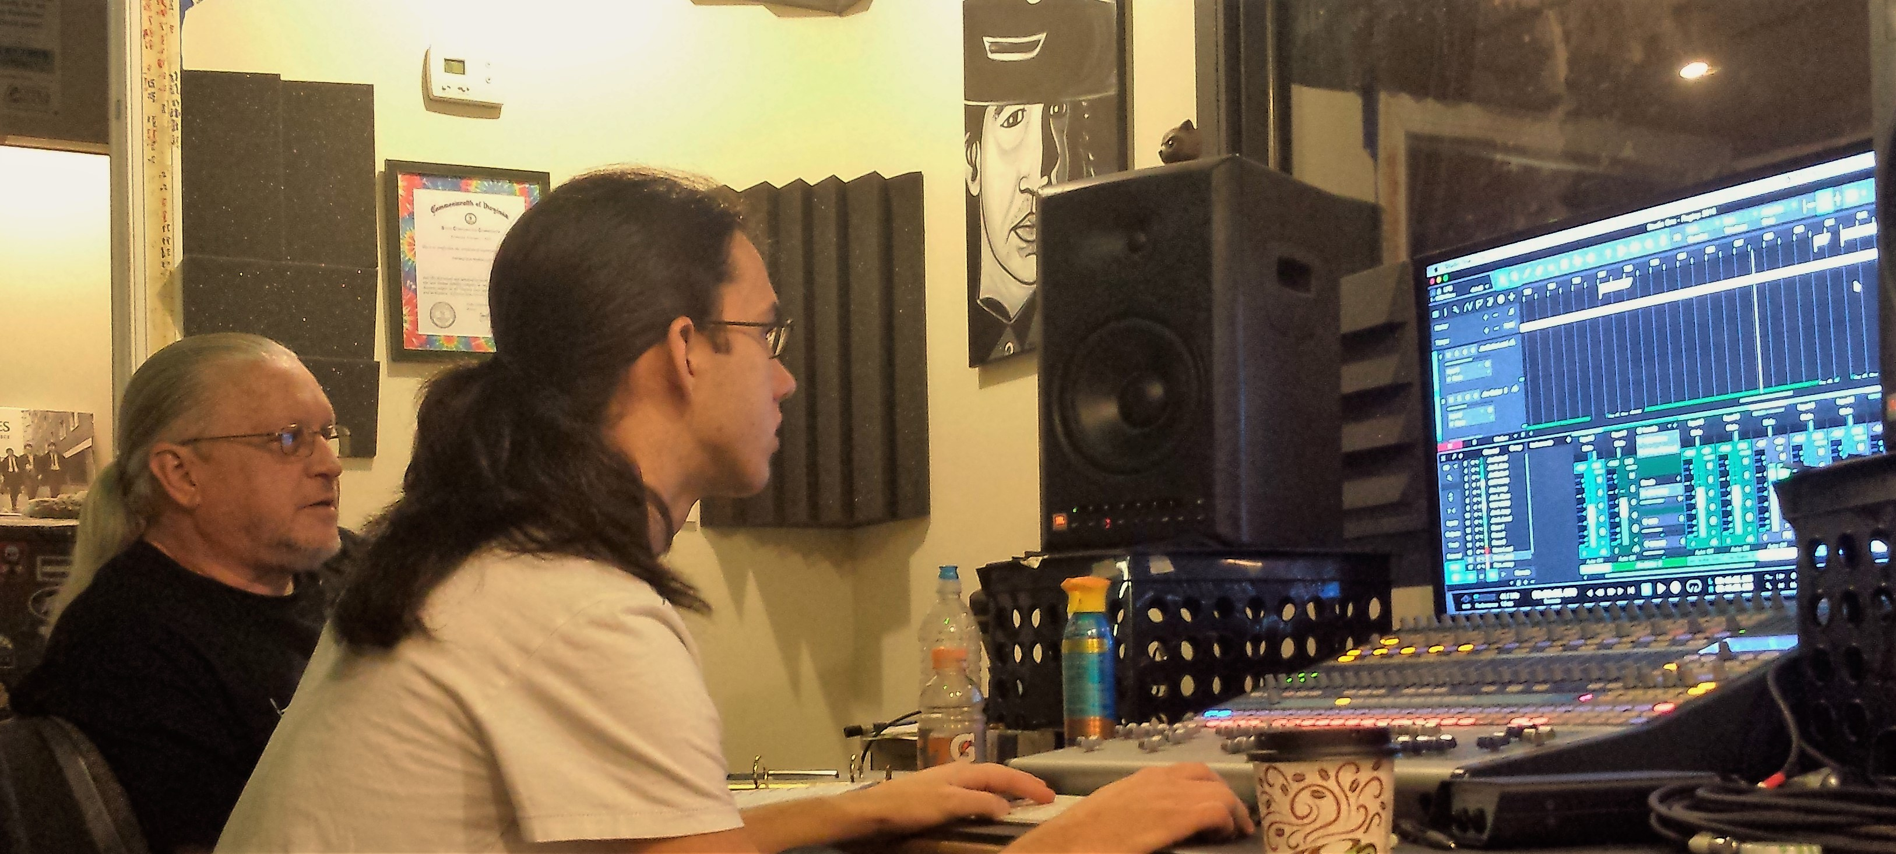  When the recording is done the mix down begins |   Willy Gurley at Fainting Goat Studio Bedford, VA

Midnight Train to Georgia

"Midnight Train to Georgia" is a 1973 number-one hit single for Gladys Knight & the Pips written by Jim Weatherly "Midnight Train to Georgia" won the 1974 Grammy for Best R&B Vocal Performance By A Duo, Group or Chorus.

The song was originally titled, “Midnight Plane to Houston”. Weatherly says, "I wrote it as a kind of a country song. Then we sent the song to a guy named Sonny Limbo in Atlanta and he wanted to cut it with Cissy Houston... he asked if I minded if he changed the title to "Midnight Train to Georgia". And I said, 'I don't mind. Just don't change the rest of the song.'"

Weatherly was in a recreational football league with Lee Majors and called Majors one night. Farrah Fawcett answered the phone and he asked her what she was doing. She said she was "taking the midnight plane to Houston" to visit her family. He thought that was a catchy phrase for a song, and in writing the song, wondered why someone would leave LA on the midnight plane - which brought the idea of a "superstar, but he didn't get far."

Our arrangement is a straight forward homage to Gladys Knight's version – to us this is her song and will always be her song. We put a simple finger-style guitar arrangement under the vocals and highlight the signature riffs in a way that complements the melody line.

Featuring: Renee Oliphant, Vocals
Jim Oliphant, Guitar

Ocean

Ocean was written by Hanna – McEuen, a country music duo comprised of first cousins Jamie Hann and Jonathan McEuen. Their fathers, Jeff Hanna and John McEuen co-founded the Nitty Gritty Dirt Band. Although this song never charted it is a favorite of ours. Our family loves spending time together at the ocean.

We dedicated this song to my mother, Sonia Oliphant. We finished recording this album on Wednesday January 4th. We had been working on the album for some time and had already booked the studio and planned to spend the afternoon of January 4, 2017 in the studio wrapping it up. My mother passed away at 3:43 pm on January 3, 2017. Family that was able, had begun gathering with her in her room in a memory care center in Hutchinson, MN on that previous Saturday morning. She had been in the end stage Alzheimer's/dementia and was in hospice care and had taken a significant change for the worse so family was called. The rest of us were able to video conference over some computer tablets and phones and the family vigil continued for the next four days.

My mother loved the ocean. Her grandmother that raised her early in her life loved to go to Ft. Myers, Florida and spend time at the ocean. So I guess it has been a part of our family for generations. We will return to our favorite family gathering spot at the ocean again, one more time as a family. My mother donated her body to the University of Minnesota for medical research and asked that upon the return of her ashes that the family gather at the beach for a memorial and spread her ashes there.

“I think I'll go down to the ocean. I think I'll go down and lie by the sea. Sit alone and watch the waves break. Don't think I'm ever going to leave.”

Featuring: Renee Oliphant, Vocals and Rock Shaker
Jim Oliphant, Guitar
(the ocean sounds at the beginning and end of the song were taken from video of our trips to the beach together)

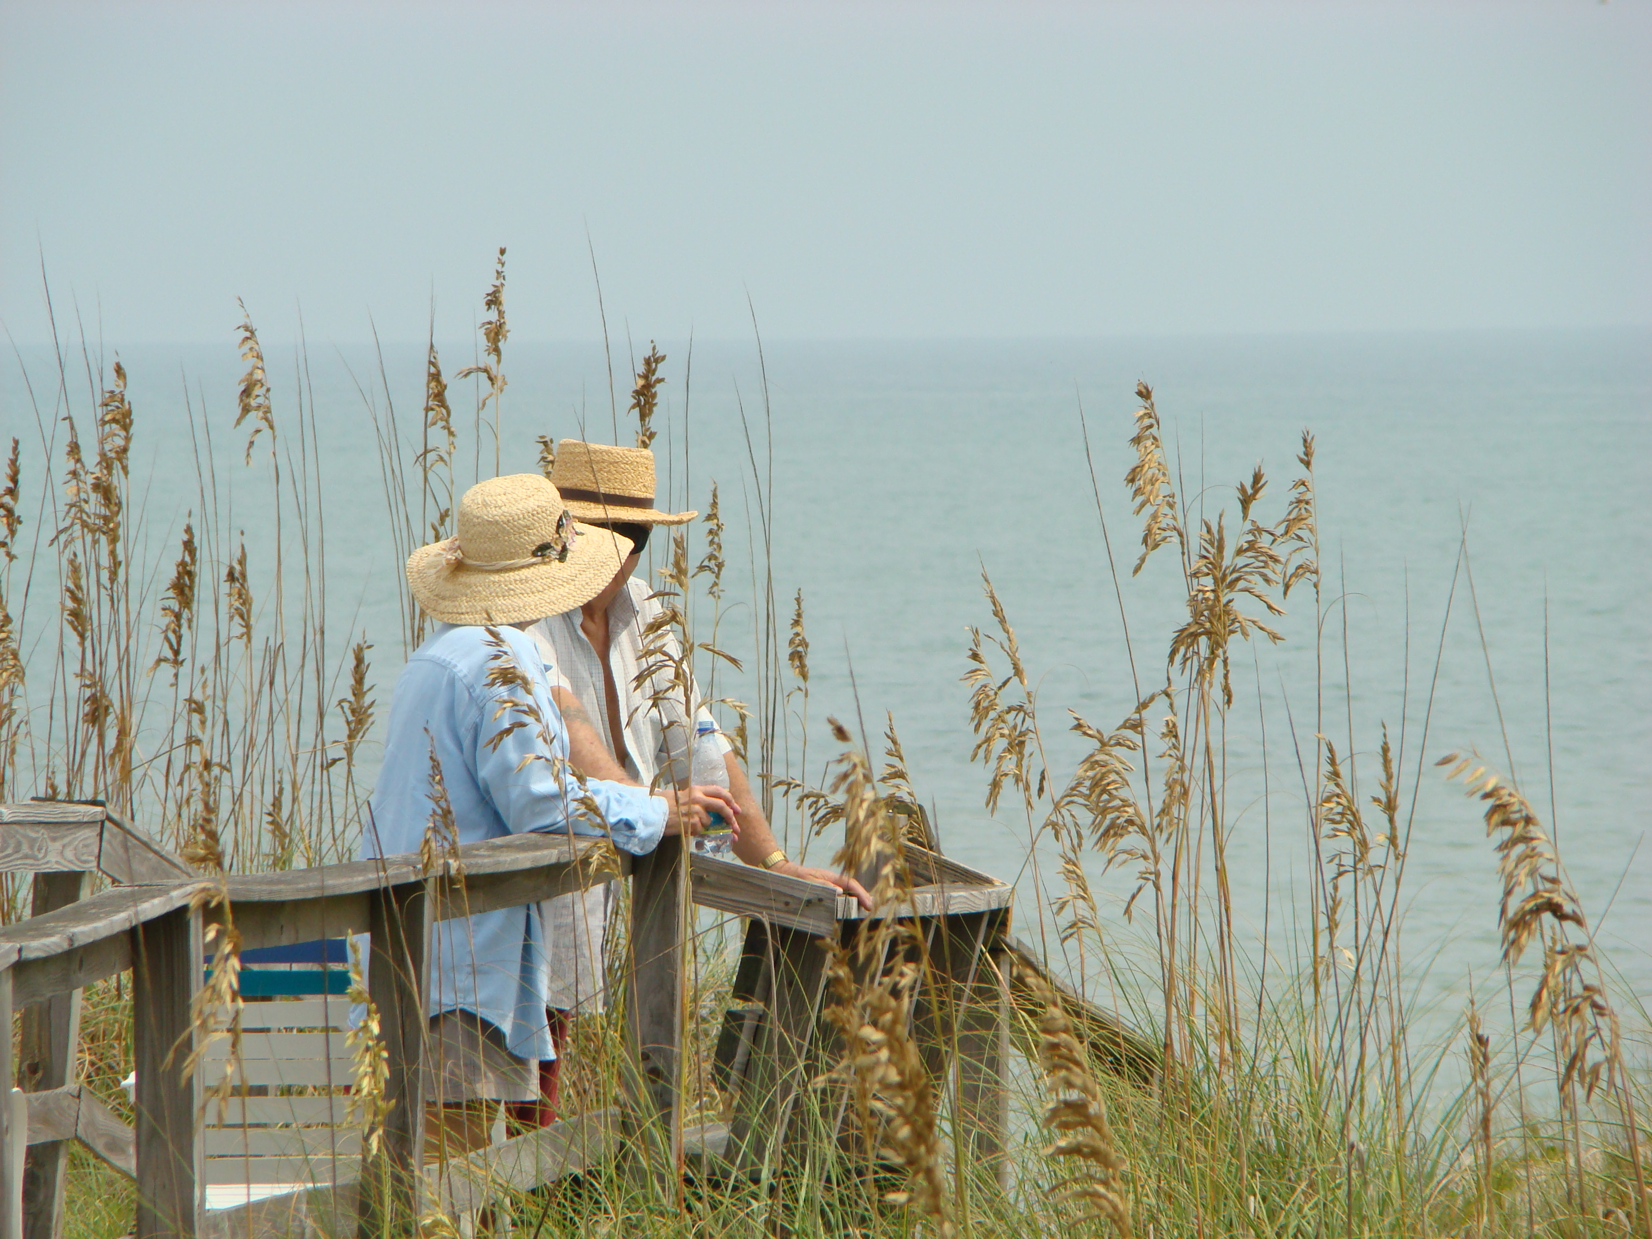 | 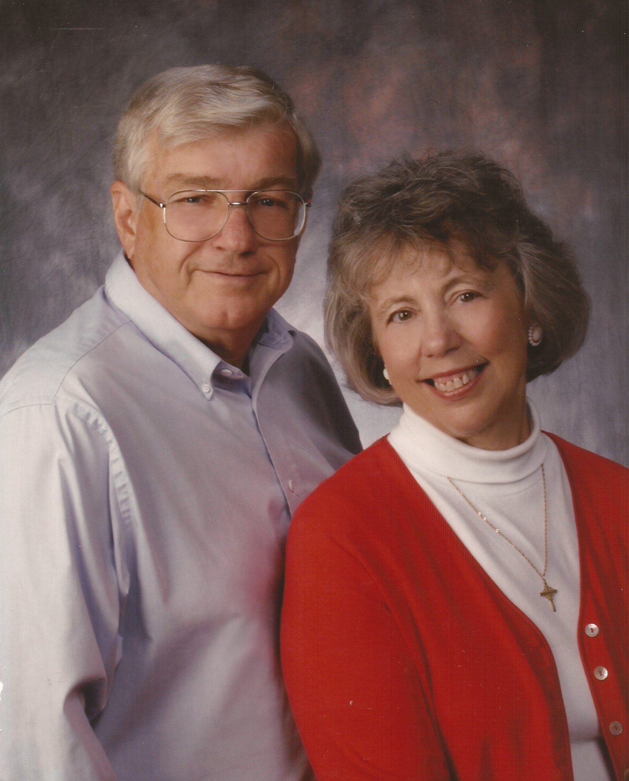 | 

